**Abstract:**

This paper puts forward the design method of network chat system based on Socket and cloud computing technology. Socket interface is an application programming interface of TCP/IP network, this interface definition of a number of functions or routine, programmers can use them to the development of TCP / IP network applications. Java Socket is tailored for the Java language by SUN which is used to develop network application program. This paper reference as the predecessor's research achievements, this paper introduces the Socket interface and cloud computing technology is an important concept of, analyzes the Socket communication mechanism in principle, this paper studies the application of Java Socket, In order to improve the communication network chat in the data stored safety and efficiency, specifically in the Socket technology application based add on cloud computing technology to the improvement of the method.

**Published in:**[2012 International Conference on Computer Science and Service System](https://ieeexplore.ieee.org/xpl/conhome/6392590/proceeding)

**Date of Conference:**11-13 Aug. 2012

**Date Added to IEEE *Xplore*:**31 December 2012

**ISBN Information:**

**INSPEC Accession Number:**13226861

**DOI:**[10.1109/CSSS.2012.157](https://doi.org/10.1109/CSSS.2012.157)

**Publisher:**IEEE

**Conference Location:**Nanjing, China

**SECTION I.**

Introduction

Today's network times, “Network” this word already thorough popular feeling, the development of computer network speed is amazing, it greatly reduces the human distance, and it apparently expanded the computer functions. And as one of network application chatting tools, it is also more and more attention by people and welcome, a good network chat tool can make any distance communication convenient and quick. In fact, in modern social network chat software development has quite mature, all kinds of complete function and friendly interface of software is quite beautiful. There into, based on the Socket of the chat system is such communication software one of the specific examples, it is good to interpret the Socket communication principle, and it in the enterprise internal communication, teaching, and discussed the application of certain practical value. It is based on TCP connection between two processes of end-to-end communication mechanism. It has to send and receive information fast speed, good secrecy, take up the network bandwidth resources is low, take up the server low throughput capacity, easy to the programming, etc[1].

**SECTION II.**

Cloud Computing *Technology*

**A. Cloud Computing Principle**

Cloud computing is distributed processing, parallel processing and the development of grid computing, or is it the computer science concept of commercial realized.

Cloud calculative fundamental is, through the analysis of the distribution of the distributed computer, rather than the local computer or the remote server, the operation of the enterprise data center will be more similar as Internet. This makes the enterprise can will resource switch on the application of need, according to demand access to the computer and storage system. This is a kind of revolutionary act, for example, this is just like is the old single generator model turned to the power plant to centralized power supply mode. It means computational ability to also can serve as a kind of goods circulation, as gas, water and electricity, take with convenient, fare is low. The biggest different depend on, it is through the Internet for transmission[2]. Cloud computing has the blueprint of be vividly portrayed: in the future, only need a laptop or a mobile phone, you can realize our need through network service everything, even including supercomputing such task. From this perspective, the end user is the cloud calculative true owner. Cloud computing applications include such a new idea or new concept: the power of the world together, to give which every member of the using, as shown in Figure 1 shows.

[[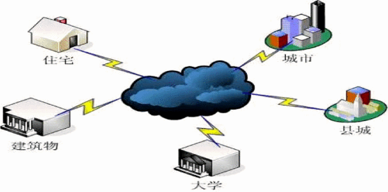](https://ieeexplore.ieee.org/mediastore_new/IEEE/content/media/6392590/6394246/6394395/6394395-fig-1-source-large.gif)](https://ieeexplore.ieee.org/mediastore_new/IEEE/content/media/6392590/6394246/6394395/6394395-fig-1-source-large.gif)

**Figure 1.**Cloud storage of cloud computing

[View All](https://ieeexplore.ieee.org/document/6394395/all-figures)

**B. “Cloud” Era**

At present, the PC is still our daily life of the core tools-we use PC documents, storage material, through E-mail or U plate and share information. If PC hard disk is broken, we will because material loss and stranded.

And in “cloud computing” era (note: the following “cloud computing” are referred to as the “cloud”), “cloud” will be done for us storage and computing work, “cloud” is computer group, and each group includes the thousands of Taiwan, or even millions of computer. “Cloud” benefits are that one of the computers can update, guarantee “cloud” forever. Google is by several such “clouds” of composition, other IT giants such as Microsoft, Yahoo and Amazon also have or are building this “cloud”[3].

At the time, we just need a computer can connect to the Internet, do not need to care about storage or computing happen where a “cloud”, but once a need, we can be in any place with any equipment, such as computers, mobile phones, fast calculation and find these material. We will no longer have to worry about material lost.

**C. The World Only Need 5 Computers**

Cloud computing is considered as the science and technology industry of the next revolution, it will bring work methods and business model of fundamental change. First of all, to small and medium enterprises and entrepreneurs for, cloud computing means huge commercial opportunity, they can use cloud computing at a higher level and large enterprise competition. Since the 1989 years since Microsoft introduced version of Office software, the way we work has been great changes, and cloud computing would bring the clouds Office, as shown in Figure 1 shows [3]:

**SECTION III**

Socket Key Technology

Socket and can be regarded as two program in one of the communication link endpoint, a program will write a message in the Socket, the Socket will this period of information sent to another in the Socket, it makes this period of information can be transmitted to other applications, its communication process as shown in Figure 2 below:

[[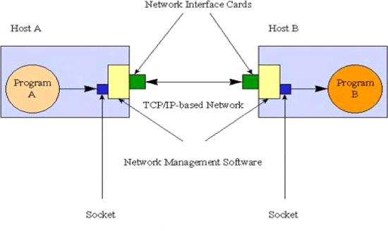](https://ieeexplore.ieee.org/mediastore_new/IEEE/content/media/6392590/6394246/6394395/6394395-fig-2-source-large.gif)](https://ieeexplore.ieee.org/mediastore_new/IEEE/content/media/6392590/6394246/6394395/6394395-fig-2-source-large.gif)

**Figure 2.**The communication schemes of Socket

[View All](https://ieeexplore.ieee.org/document/6394395/all-figures)

Java furnishes Socket-type and Server Socket-type realizing Socket communication, it handles user request and response, it is in bag of java. net Server Socket Used for the server, and it furnishes TCP connection services. Socket used in establishing network connections, it furnish marriage partner of Communication both ends, connection when success, the application will create an instance of Socket on both ends, operating this example, to complete the session[].

**SECTION IV**

Analysis And Design Of System

**A. The System Definition**

The system put completing interface design of system to use the component element AWT and Swing in Java, it build communication in both ends based on Socket port, introducing multithreading technology realize concurrent execution, using JDBC database connection technology to create a database connection[4].

**B. Functional Requirement**

* Function of Users Login: Through the fill in the user name and password, choose the right to enter chat room on the interface.
* Function of User Registration: Fill in and submit to a server in the personal information, server registered information will become successful after members. Submit personal information, the client to personal information of validation.
* Function of Chat Group Chat: user can choose to interface in group chat (chat room the interface) online of all users or specific users send information, and receive other customer information. Private Chat: The user can chat room facing the world in a particular user sending private chat request, the other party has accepted, both sides will enter private chat interface to private chat[5].
* Function of Warning and Kicking: The client and server administrator managers are warning and kicking through the rights to manage chat rooms.

**C. Overall Design**

System structure diagram: System structure as shown in Figure 3 shows. This system is divided into client and server two parts. The client is driven by login, registration, group chat, private chat module four function modules. The server is only one management module. If the server can use cloud computing technology, so the whole system is more efficiency and security.

* Server and Client Socket Communication Flow Diagram: Socket communication flow diagram of client and server, as shown in Figure 4 shows. After the success of the connection, the practical communication is the server Socket obj ect and client Socket objects. The chat system general flow-chart.

[[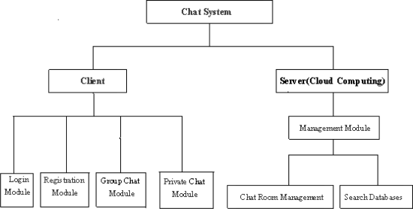](https://ieeexplore.ieee.org/mediastore_new/IEEE/content/media/6392590/6394246/6394395/6394395-fig-3-source-large.gif)](https://ieeexplore.ieee.org/mediastore_new/IEEE/content/media/6392590/6394246/6394395/6394395-fig-3-source-large.gif)

**Figure 3.**System structure diagram.

[View All](https://ieeexplore.ieee.org/document/6394395/all-figures)

[[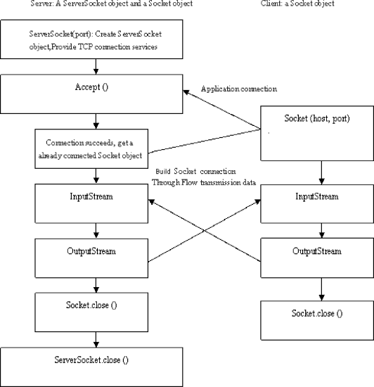](https://ieeexplore.ieee.org/mediastore_new/IEEE/content/media/6392590/6394246/6394395/6394395-fig-4-source-large.gif)](https://ieeexplore.ieee.org/mediastore_new/IEEE/content/media/6392590/6394246/6394395/6394395-fig-4-source-large.gif)

**Figure 4.**Socket communication flow diagram

[View All](https://ieeexplore.ieee.org/document/6394395/all-figures)

**D. Database Design**

* Database Base Table: This system of data has two basic form, a user is the basic information table, a basic information table is administrator, field constitute as shown in TABLE I shows[6].
* Database Connection: The system uses the JDBC technology, JTDS database driver access and manipulate the database. With JTDS database driver finished and SQL Server 2000 connection in words[]:

[[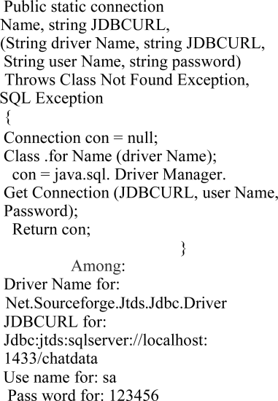](https://ieeexplore.ieee.org/mediastore_new/IEEE/content/media/6392590/6394246/6394395/6394395-alg-1-source-large.gif)](https://ieeexplore.ieee.org/mediastore_new/IEEE/content/media/6392590/6394246/6394395/6394395-alg-1-source-large.gif)

**TABLE I.**Userinfor

| **Field** | **Type Name** | **Description** | **For null** |
| --- | --- | --- | --- |
| userID | int | user number | not null |
| userName | varchar(20) | user name | not null |
| userPwd | varchar(20) | user password | not null |
| trueName | varchar(20) | real name |  |
| country | varchar(20) | respective countries |  |
| fav | varchar(20) | hobby |  |
| telphone | varchar(20) | contact way |  |

**E. Detailed Design**

* Login Module Design: This module will need a graphical user interface, for the user to enter your user name and password, and select login role.
* Registered Module Design: This module will need a graphical user interface, for user input personal information, need special mark required fields, and to the input information for verification[7].
* Chat Module Design: This module will need two graphical user interface, the world face and a private chat room chat interfaces, user chat of the main places. The user can accord to the personal like, selection of the group chat or secret private chat.
* The Server Management Module Design: This module will need a graphical user interface, running on the server management of start-up and closed Socket, forward user chat messages, and the management of the chat rooms.

**SECTION V.**

Development And Realization of System

**A. The Realization of System User Interface[8]**

* Login Interface: This system login Interface is the user into the chat room of the registration and interface of the entrance. The login Interface uses set Bounds (int x, int y, int width, int height) Methods to achieve each component in the picture of the positioning.
* Register Interface: This system register Interface is to provide users to fill out and submit the server to the entrance of the personal information. The register Interface uses set Bounds (int x, int y, int width, int height) Methods to achieve each component in the picture of the positioning.
* Chat Room Interface: This system Chat room interface using the sending and receiving chat messages. This interface use JAVA layout manager to screen for layout, first JFrame set the layout of the manager for Border Layout, and then, in Border Layout to add JPanel components, and set the layout manager for Box Layout, finally in JPanel added the necessary basic components picture.
* The Server Interface of The Lord: Server administrators through this interface start and stop the Socket and send system information.

**B. The Client of Communication Between Realized**

* The Client the Creation of A Socket
* The Server The Creation of A Socket

[[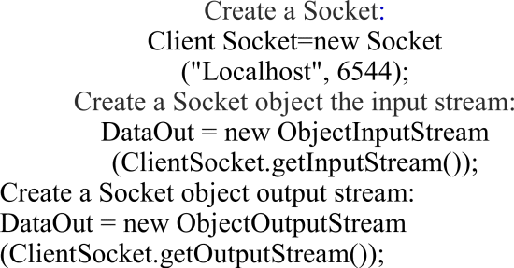](https://ieeexplore.ieee.org/mediastore_new/IEEE/content/media/6392590/6394246/6394395/6394395-alg-4-source-large.gif)](https://ieeexplore.ieee.org/mediastore_new/IEEE/content/media/6392590/6394246/6394395/6394395-alg-4-source-large.gif)

[[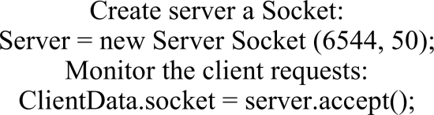](https://ieeexplore.ieee.org/mediastore_new/IEEE/content/media/6392590/6394246/6394395/6394395-alg-5-source-large.gif)](https://ieeexplore.ieee.org/mediastore_new/IEEE/content/media/6392590/6394246/6394395/6394395-alg-5-source-large.gif)

**C. Realize Part CLASS of the System**

* Server-Side
* Client Members
* Client Login and Registered

[[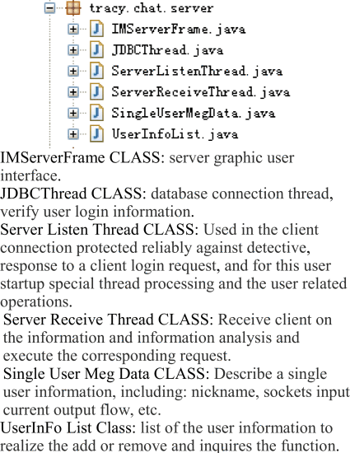](https://ieeexplore.ieee.org/mediastore_new/IEEE/content/media/6392590/6394246/6394395/6394395-alg-6-source-large.gif)](https://ieeexplore.ieee.org/mediastore_new/IEEE/content/media/6392590/6394246/6394395/6394395-alg-6-source-large.gif)

[[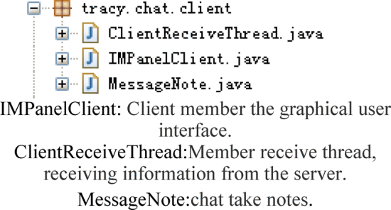](https://ieeexplore.ieee.org/mediastore_new/IEEE/content/media/6392590/6394246/6394395/6394395-alg-7-source-large.gif)](https://ieeexplore.ieee.org/mediastore_new/IEEE/content/media/6392590/6394246/6394395/6394395-alg-7-source-large.gif)

[[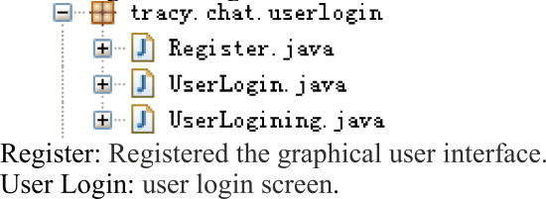](https://ieeexplore.ieee.org/mediastore_new/IEEE/content/media/6392590/6394246/6394395/6394395-alg-8-source-large.gif)](https://ieeexplore.ieee.org/mediastore_new/IEEE/content/media/6392590/6394246/6394395/6394395-alg-8-source-large.gif)

**SECTION VI.**

Conclusion

This paper introduces a Socket communication principle and the application in JAVA, and on this basis, to a network chat system development process was described. The system is based on Socket and cloud computing concept realized by the point-to-point chat system, through the Java Swing components provide the powerful graphics interface editing functions, create a user interface of beautiful and friendly, and combined with Java multithreading technology realize the client chat messages of sending and receiving, many users group chat and point to some private chat the concurrent execution, etc. Cloud computing is a kind of Internet super calculation mode, in a remote data center, hundreds of thousands of computers and servers connected to a computing cloud. Therefore, cloud computing can even let you experience ten trillion times per second of the operation ability, have so powerful computing power can simulate a nuclear blast, predict climate change, market development trend and chat online data storage. No matter where the world the user can through the computer, mobile phone and cloud computing access the way data center, you can be more efficient, safe to chat and the Internet, according to the needs of their proceed computing [3].

**Authors**

**Figures**

**Figure 1.**

View in Context[Show Full Size](https://ieeexplore.ieee.org/mediastore_new/IEEE/content/media/6392590/6394246/6394395/6394395-fig-1-source-hires.gif)

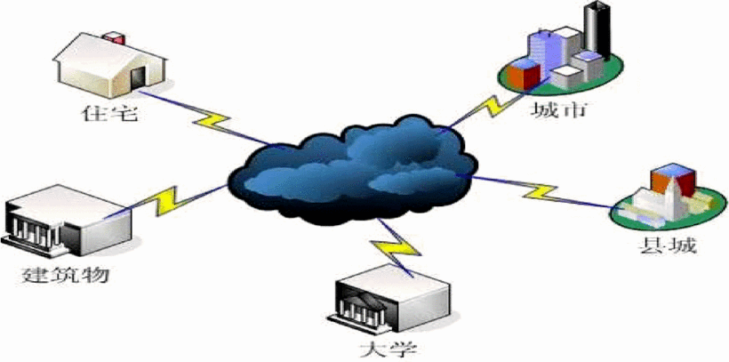

Cloud storage of cloud computing

**Figure 2.**

View in Context[Show Full Size](https://ieeexplore.ieee.org/mediastore_new/IEEE/content/media/6392590/6394246/6394395/6394395-fig-2-source-hires.gif)

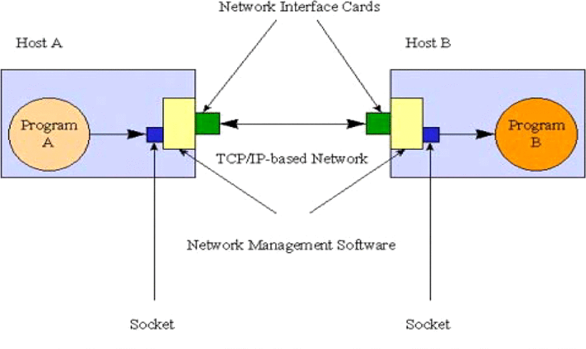

The communication schemes of Socket

**Figure 3.**

View in Context[Show Full Size](https://ieeexplore.ieee.org/mediastore_new/IEEE/content/media/6392590/6394246/6394395/6394395-fig-3-source-hires.gif)

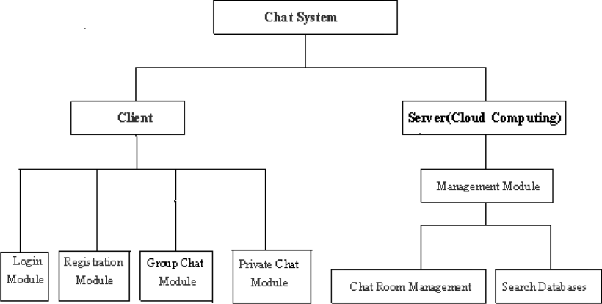

System structure diagram.

**Figure 4.**

View in Context[Show Full Size](https://ieeexplore.ieee.org/mediastore_new/IEEE/content/media/6392590/6394246/6394395/6394395-fig-4-source-hires.gif)

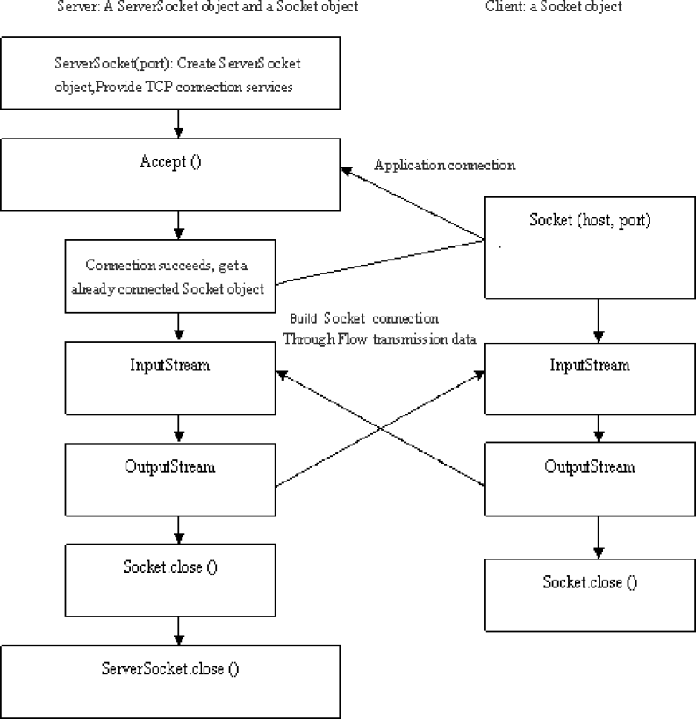

Socket communication flow diagram